E.L.L.E
[ Environmental Lens for Liquid Evaluation]
PROJECT REPORT
Submitted by
Shruti Dewaskar - 23BCE10134
Vaibhav Mishra - 23BCE10616
Nabh Garg - 23BCE10635
Ayush Chandra - 23BCE10461
Shristi Jha - 23BHI10125
Riddhiraj Roy - 23BEC10001
in partial fulfillment of the requirements for the degree of
Bachelor of Technology

VIT Bhopal University
Bhopal, Madhya Pradhesh

<<February, 2026>>

BONAFIDE CERTIFICATE

Certified that this project report titled Microplastic Detection in Water Sample is the bonafide work of Shruti Dewaskar - 23BCE10134 Vaibhav Mishra - 23BCE10616 Nabh Garg - 23BCE10635 Ayush Chandra - 23BCE10461 Shristi Jha - 23BHI10125 Riddhiraj Roy - 23BEC10001 who carried out the project work under my supervision. Certified further that to the best of my knowledge the work reported at this time does not form part of any other project/research work based on which a degree or award was conferred on an earlier occasion on this or any other candidate.

PROGRAM CHAIR, | PROJECT SUPERVISOR,

The Project Exhibition II is held on

Declaration of Originality

We, hereby declare that this report entitled <“ Microplastic Detection in Water Sample''> represents our original work carried out for the EPICS project as a student of VIT Bhopal University and, to the best of our knowledge, it contains no material previously published or written by another person, nor any material presented for the award of any other degree or diploma of VIT Bhopal University or any other institution. Works of other authors cited in this report have been duly acknowledged under the section ''References''.

 | Date- 13/2/26 | Reg No & Name  23BCE10134- Shruti Dewaskar  23BCE10616-Vaibhav Mishra  23BCE10635 - Nabh Garg  23BCE10461 - Ayush Chandra  23BHI10125 - Shristi Jha  23BEC10001-Riddhiraj Roy  (also signed by all students)

ACKNOWLEDGEMENT

First and foremost, I would like to thank the Lord Almighty for His presence and immense blessings throughout the project work.

I wish to express my heartfelt gratitude to Dr E Nirmala, Program Chair for much of his valuable support and encouragement in carrying out this work.

I would like to thank all the technical and teaching staff of the School Computing Science and Engineering, who extended directly or indirectly all support.

Last, but not least, I am deeply indebted to my parents who have been the greatest support while I worked day and night for the project to make it a success.

Abstract

In the present work, we had designed and developed a web‑based microplastic analysis interface that wraps our detection models into an interactive prediction and visualization tool. The core component is a Flask application (web_predict.py) that allows users to upload microscope images of water samples through a browser. On each request, the server saves the image, forwards it to a unified inference function, and receives bounding boxes, class scores, and per‑class counts. The application then overlays detections directly on the image using OpenCV and returns both the original and annotated images to the user interface.
Beyond visual overlays, the web layer aggregates detection counts into a high‑level “pollution summary”, classifying each sample as “OK”, “Little Pollution”, or “Very Polluted” using fixed thresholds. It also logs recent predictions to a JSON file and computes a rolling trend, which is used to generate a simple drinking‑water recommendation (likely safe, caution, or not safe). Additional routes expose system status and health information for debugging and deployment monitoring, as well as static pages such as “About” and “Docs”. Overall, web_predict.py turns low‑level model outputs into an accessible, decision‑oriented web experience for end users.

FIGURE NO. | TITLE | PAGE NO.
1 | Architecture Diagram of ML-Based Vulnerability Scanner | 14
2 | Sample Web Interface (Home Page) | 16
3 | Code Submission and Response UI | 18
4 | Confusion Matrix of the Trained Model | 19
5 | ROC Curve for Vulnerability Detection Classifier | 25
6 | Accuracy, Precision, Rrt | 26
7 | Probability Confidence Distribution for Safe vs Vulnerable Predictions | 29
8 | Screenshot of result.html Displaying Performance, Syntax, and Security Meters | 34
9 | Bar Chart Visualization of Efficiency, Syntax Compliance, and Security Score (Frontend) | 35
10 | Sample Output of Detected Vulnerabilities in a C/C++ Code Snippet | 40
11 | End-to-End Workflow Diagram of Data Input, Processing, and Output | 41
LIST OF TABLES

TABLE NO. | TITLE | PAGE NO.
1 | Dataset Description – Distribution of Vulnerable vs Non-Vulnerable Code Samples | 13
2 | Examples of Python Code Snippets Used for Training and Testing | 15
3 | Description of Features Extracted via TF-IDF Vectorization | 16
4 | Parameters and Hyperparameters of the Random Forest Classifier | 18
5 | Evaluation Metrics of the Model (Accuracy, Precision, Recall, F1-Score) | 21
6 | Comparative Analysis Between Rule-Based Detection and ML-Based Detection | 25
7 | Detected Vulnerabilities and Corresponding Descriptions from Test Code Snippets | 26
8 | Security Score Ratings and Their Interpretation Criteria (Secure, Moderate, Insecure) | 27
9 | Frontend Technologies Used and Their Purpose | 33
10 | Integration Mapping Between Backend API and Frontend Visualizations | 39

ABSTRACT

With increasing security concerns in educational and public spaces, traditional CCTV systems fall short in providing proactive threat detection. This project proposes a smart surveillance solution titled "Real-Time Emotion and Threat Detection Using AI and IoT-Based CCTV Surveillance" that leverages machine learning and Python-based frameworks to enhance situational awareness and security. The system integrates real- time video feeds from IoT-enabled CCTV cameras with advanced emotion recognition and behavioral analysis models. Using Convolutional Neural Networks (CNNs), the system identifies facial expressions—such as anger, fear, or distress—while Long Short- Term Memory (LSTM) networks track emotional transitions to detect anomalies or potential threats over time.
Built using Python libraries such as OpenCV, TensorFlow, and Flask, the application performs on-device inference using edge devices like Raspberry Pi or NVIDIA Jetson for low-latency response. A cloud-connected dashboard enables live monitoring, threat.

alerts, and data visualization, ensuring swift response and decision-making. The system is trained on benchmark datasets like FER-2013 and AffectNet to ensure high accuracy across diverse environments. This hybrid edge-cloud architecture enables real-time, context-aware surveillance, transforming passive video monitoring into an intelligent, proactive security system. The project aims to deliver a scalable and ethical AI-powered framework for modern surveillance needs.
CHAPTER  NO. | TITLE | PAGE NO.
 | List of Abbreviations | 4
 | List of Figures and Graphs | 5
 | List of Tables | 6
 | Abstract | 7
1 | Chapter 1:  Project Description and Outline  1.1 Introduction  1.2 Motivation for the Work  1.3 Introduction to the Project and Techniques  1.4 Problem Statement  1.5 Objective of the Work: Defining Measurable Goals for Project Success | 12  12  13  14  15  15
2 | Chapter 2:
 | Related Work Investigation - A Comprehensive Review of | 17
 | Vulnerability Detection Techniques
 | 2.1 Core Area of the Project: Leveraging Machine Learning for | 17
 | Enhanced Static Code Analysis
 | 2.2 Machine Learning with Feature Engineering | 18
 | 2.3 Issues and Observations from Literature Review: Identifying | 20
 | Gaps and Opportunities
3 | CHAPTER 3 :
 | REQUIREMENT ARTIFACTS | 22
 | 3.1 Hardware and Software Requirements | 22

 | CHAPTER 3: Requirement Artificats  3.1.1 Hardware Requirements  3.1.2 Software Requirements  3.2 Specific Project Requirements  3.2.1 Data Requirements  3.2.2 Functional Requirements  3.2.3 Performance and Security Requirements  3.2.4 Look and Feel Requirements  3.2.5 Miscellaneous Requirements | 22  23  23  23  24  24  25  25
4 | CHAPTER 4 :  DESIGN METHODOLOGY AND ITS NOVELTY  4.1 System Architecture  4.1.1 User Interface Layer  4.1.2 Preprocessing and Tokenization  4.1.3 Feature Extraction with TF-IDF  4.1.4 Vulnerability Detection using Random Forest  4.1.5 Result Interpretation and Reporting  4.2 Algorithmic Workflow  4.3 Novelty of the Proposed Method  4.3.1 ML Integration in Traditional Static Analysis  4.3.2 Language-Agnostic Vectorization  4.3.3 Real-Time Prediction with Web Interface  4.3.4 High Detection Accuracy and Low False Positives  4.3.5 Open Dataset Usage and Transparency | 26  26  27  27  27  27  28  28  29  29  29  29  30  30
5 | CHAPTER 5 :  IMPLEMENTATION AND TESTING  5.1 Implementation Details  5.1.1 Development Environment  5.1.2 ML Model Development  5.1.3 Web Application Front-End  5.2 Testing Strategy  5.3 Evaluation Metrics  5.4 Results and Analysis | 31  31  32  33  33  34  34  35

6 | CHAPTER 6 :  RESULTS AND DISCUSSIONS  6.1 Experimental Setup  6.2 Performance Metrics  6.3 Experimental Results  6.4 Limitations  6.5 Future Enhancements | 36  36  36  37  37  38
7 | CHAPTER 7 :  CONCLUSION AND FUTURE SCOPE  7.1 Major Contributions  7.2 Limitations  7.3 Future Scope | 39  39  40  40
 | References | 41

Chapter 1: Project Description and Outline

1.1 Introduction

In today’s interconnected world, surveillance systems are no longer limited to passive monitoring—they are evolving into intelligent guardians capable of interpreting and responding to human behavior in real time. With increased reliance on public and institutional safety infrastructure, the ability to detect emotional and behavioral cues has become critical. However, traditional CCTV systems fall short, offering delayed and often reactive responses that miss early indicators of threats such as violence, panic, or aggression.
Historically, security surveillance has relied heavily on human operators to monitor and assess behavior, which is labor-intensive and prone to oversight, especially in large-scale environments like educational campuses. Although deep learning has empowered modern surveillance systems to analyze complex emotional patterns, its deployment is often limited by high computational demands and lack of explainability—especially on edge devices with limited processing power.
To overcome these limitations, our project proposes an intelligent, real-time emotion and threat detection framework that leverages a hybrid architecture of AI, IoT, and edge-cloud computing. The system utilizes lightweight Convolutional Neural Networks (CNNs) for facial emotion recognition and Long Short-Term Memory (LSTM) networks for detecting behavioral anomalies over time. These models are deployed on edge devices such as Raspberry Pi and NVIDIA Jetson Nano to ensure low latency and responsiveness.
Benchmark datasets like FER2013 and AffectNet are used for training, while a TF-IDF-like approach to feature extraction informs the analysis of real-time emotion transitions. A centralized dashboard provides live video feeds, emotional analytics, and intelligent alerts to enable rapid decision-making and threat response. By combining scalability, interpretability, and efficient edge processing, this work introduces a proactive, real-world solution to enhance the safety of public spaces—transforming traditional CCTV into a powerful tool for situational awareness and prevention.

1.2 Motivation for the Work
The motivation behind this research and development effort is deeply rooted in the alarming trend of escalating cyber-attacks that specifically target exploitable software vulnerabilities. The digital landscape is increasingly fraught with malicious actors who actively seek out and leverage weaknesses in software to achieve their nefarious objectives. News headlines frequently report significant data breaches, ransomware attacks, and other security incidents that can often be traced back to the exploitation of underlying code vulnerabilities.
Existing tools and methodologies for vulnerability detection often present significant limitations. Many traditional static analysis tools, while valuable, can generate a high volume of false positives, requiring considerable expert knowledge and manual effort to sift through the results and identify genuine threats. Furthermore, these tools may struggle to effectively identify more subtle or context- dependent vulnerabilities. Conversely, while deep learning models have shown promise in various security domains, their complexity can make them less accessible to smaller development teams and may lack the transparency needed for thorough understanding and trust in their predictions.
In light of these challenges, our motivation is to develop a system that strikes a balance between effectiveness and accessibility. We aim to build a vulnerability detection tool that is not only capable of accurately identifying security flaws in prevalent programming languages such as C and C++ but is also designed with user-friendliness in mind. By providing a more accessible and efficient means of vulnerability detection, we hope to empower developers and security professionals alike to

proactively address security concerns early in the development process, ultimately contributing to a more secure software ecosystem.

1.3 Introduction to the Project and Techniques

The motivation behind this research stems from the growing need to enhance public safety through proactive and intelligent surveillance systems—particularly within educational institutions and other high-footfall environments. In an era marked by increasing incidents of campus violence, mental health crises, and public security threats, traditional CCTV systems have proven insufficient. These systems largely operate as passive observers, offering little support in recognizing emotional distress or predicting escalating situations before they unfold.
Recent advancements in Artificial Intelligence (AI), Internet of Things (IoT), and edge computing offer transformative potential for surveillance—enabling systems to not only see but also understand and respond to human behavior in real time. However, deploying such intelligent surveillance systems presents several challenges. Many existing AI-powered solutions rely on heavy cloud infrastructure, suffer from latency issues, or are not interpretable enough to gain the trust of operators and administrators. Similarly, deep learning models, while powerful, often require significant computational resources and technical expertise, making them impractical for real-time deployment on resource-constrained edge devices.
This project is motivated by the need to bridge this gap by designing a system that balances intelligence, speed, and accessibility. By combining lightweight CNN and LSTM models with edge processing on devices like Raspberry Pi and Jetson Nano, we aim to deliver a responsive, interpretable, and scalable solution for real-time emotion recognition and threat detection. Our goal is to empower institutions to detect early warning signs—such as anger, fear, or unusual behavior—and respond swiftly to potential threats, thereby fostering safer and more resilient environments.

1.4 Problem Statement

Problem Statement
The central problem addressed by this project can be formally stated as follows:
· To design and implement a machine learning-driven, web-based surveillance framework capable of accurately and efficiently detecting real-time emotional states and potential threats within public or institutional environments using CCTV footage and IoT-enabled edge devices. This system should leverage advanced deep learning techniques and temporal behavior analysis to automatically identify suspicious activities or emotional anomalies—such as aggression, panic, fear, or distress—captured through live video streams.
This project aims to overcome several key challenges in current surveillance systems. Traditional CCTV infrastructure functions primarily as a passive monitoring tool, often limited to providing post-incident evidence rather than real-time threat prevention. Furthermore, even systems augmented with basic AI capabilities frequently lack contextual understanding, real-time responsiveness, or the ability to process continuous emotional dynamics effectively.
The solution proposed in this work integrates cutting-edge computer vision techniques using Convolutional Neural Networks (CNNs) for facial emotion classification, combined with Long Short-Term Memory (LSTM) networks to analyze temporal emotional transitions and detect anomalies in behavior. These models are trained on widely accepted benchmark datasets, such as FER2013 and AffectNet, to ensure a high degree of accuracy and generalizability.
To address latency and scalability, the system employs edge computing through devices like NVIDIA Jetson Nano and Raspberry Pi, allowing real-time inference directly at the data source. This design significantly reduces network load and ensures timely threat detection even in low-connectivity scenarios.
A user-friendly, web-based dashboard developed with React and Flask provides security personnel with real-time visualizations, alerts, emotional analytics, and incident logs. The backend supports hybrid data management using MongoDB for unstructured emotional metadata and MySQL for structured logs and system status tracking.
This problem statement encapsulates the core technical and practical challenges of the project: selecting appropriate machine learning models, optimizing them for edge deployment, integrating them into a scalable surveillance architecture, and validating the solution’s effectiveness using both simulation and real-world deployment scenarios. Ultimately, the project strives to transform traditional surveillance systems into intelligent, proactive security solutions capable of recognizing and mitigating potential threats in real time, thereby contributing to safer educational and public spaces.

1.5 Objective of the Work: Defining Measurable Goals for Project Success

To effectively address the problem statement, this project is guided by the following specific and measurable objectives:

• To analyze existing methods of intelligent surveillance and behavioral threat detection:
This objective involves a comprehensive review of current technologies and frameworks employed in modern surveillance systems, including facial emotion recognition, anomaly detection techniques, and the use of edge-cloud architectures in real-time video analytics. This background study will help identify limitations in traditional systems and highlight opportunities for innovation using AI and IoT.

• To develop deep learning models for real-time emotion and threat detection:
This goal focuses on the core technical contribution of the project. It includes selecting and training Convolutional Neural Networks (CNNs) for facial emotion recognition and Long Short-Term Memory (LSTM) networks for analyzing temporal emotional transitions and behavioral anomalies. The models will be trained on benchmark datasets like FER2013 and AffectNet to ensure reliable classification across diverse emotional states and environmental conditions.

• To deploy the AI models on edge computing devices for real-time inference:
This objective ensures practical implementation by integrating the trained models into compact edge devices such as Raspberry Pi and NVIDIA Jetson Nano. This deployment aims to enable local, low-latency inference from live CCTV streams, ensuring rapid detection without full reliance on cloud infrastructure, thereby improving responsiveness and scalability.

• To integrate the system into a fully functional web-based surveillance dashboard:
This goal involves building an interactive, user-friendly web application using React (frontend) and Flask (backend), through which security personnel can monitor real-time CCTV feeds, receive emotion-based alerts, view heatmaps, and analyze behavioral trends. This application will act as the control center for visualization, decision-making, and response.

• To test and validate the system using real-world scenarios and benchmark datasets:
This objective highlights the importance of rigorous performance evaluation. The system will be validated through controlled experiments and simulations using video footage and datasets with labeled emotional and behavioral patterns. Evaluation metrics such as accuracy, precision, recall, F1-score, latency, and alert responsiveness will be used to assess the effectiveness of both the emotion recognition and threat detection components.

Chapter 2: Related Work Investigation - A Comprehensive Review of Vulnerability Detection Techniques
Over the past several years, the domain of intelligent surveillance and real-time threat detection has undergone remarkable transformation, with a wide array of technologies emerging to address the growing need for proactive security systems. These approaches range from traditional rule-based video analytics and manual monitoring by human operators to cutting-edge, fully automated frameworks that leverage artificial intelligence (AI) to interpret emotional and behavioral patterns in real time with minimal human input.
This chapter aims to provide a comprehensive exploration of the evolution of surveillance technologies related to emotion recognition and behavioral threat analysis. We begin with an examination of conventional surveillance systems, which primarily rely on human interpretation of CCTV footage—often reactive and prone to oversight. We then move on to review advancements in computer vision, particularly in the use of Convolutional Neural Networks (CNNs) for facial emotion recognition, which have significantly improved the ability to detect subtle affective states from video input.
Further, we will explore the integration of temporal models such as Long Short-Term Memory (LSTM) networks that enhance context-awareness by analyzing sequences of emotional transitions—offering deeper insight into evolving situations such as escalating aggression or crowd panic. Additionally, we assess the role of edge computing and hybrid cloud-edge architectures, which address key challenges such as latency, bandwidth limitations, and scalability.
This comparative study is essential for understanding the current state of the art in intelligent surveillance and emotion-aware systems. It provides critical insights into the strengths and limitations of various methodologies and helps position our project within this technological landscape. By examining the gaps and opportunities identified in existing systems, we highlight the unique contributions of our approach—particularly its focus on real-time, context-aware threat detection through lightweight AI models deployed on IoT-enabled edge devices. Ultimately, this literature review establishes the foundation for our work, justifying its relevance and outlining the value it aims to bring to the future of smart security infrastructures.

2.1 Core Area of the Project: Leveraging Machine Learning for Enhanced Static Code Analysis

Software security remains a critical concern across modern application development, particularly in low-level programming environments where vulnerabilities can lead to severe consequences. Traditional methods such as dynamic testing assess software by executing it and monitoring runtime behavior to uncover faults. While effective, these approaches often identify issues late in the development cycle, increasing remediation cost and risk. In contrast, static code analysis inspects source code directly, without execution, enabling earlier detection of potential vulnerabilities—often before the software is even compiled or deployed.
This project introduces an intelligent static code analysis framework that integrates machine learning (ML) with traditional program inspection techniques to build a lightweight and automated vulnerability scanner. Designed for Python-based implementation, the system operates on vectorized code representations generated through Term Frequency-Inverse Document Frequency (TF-IDF), which transforms source code into structured numerical vectors. These vectors reflect the significance of code elements within a larger corpus, allowing machine learning models to extract meaningful patterns from raw syntax.
Focusing on the C and C++ programming languages—both widely used and inherently prone to memory-related security flaws such as buffer overflows, pointer dereferencing errors, and stack corruption—the proposed system employs a Random Forest classifier trained on curated datasets of vulnerable and non-vulnerable code. The ensemble nature of Random Forest, combined with its resilience to overfitting and capacity to process high-dimensional feature spaces, makes it a robust solution for classifying complex code structures and identifying potential security threats early in the software lifecycle.

2.2 Existing Approaches/Methods: A Survey of Techniques in Vulnerability Detection

The field of software vulnerability detection has witnessed the development and application of various techniques, each with its own set of strengths and limitations. This section provides an overview of some of the prominent existing approaches and methods.

2.2.1 Traditional Static Analysis Tools:

Traditional static analysis tools have been a cornerstone of software security for many years. These tools operate by examining the source code based on a predefined set of rules and patterns that are known to be associated with common vulnerabilities. Some well-known examples include:
· Cppcheck: This tool is specifically designed for C and C++ code and excels at detecting a range of issues, including memory leaks (where dynamically allocated memory is not

properly freed), null pointer dereferencing (attempting to access memory through a null pointer), and buffer overflows (writing data beyond the allocated boundaries of a buffer). Cppcheck often relies on symbolic execution and value analysis to identify these potential flaws.
· Flawfinder: Flawfinder focuses specifically on identifying security flaws in C and C++ source code. It operates by scanning the code for instances of known "dangerous functions" – functions that have historically been associated with security vulnerabilities if not used carefully. Flawfinder assigns risk levels to the identified instances based on the potential severity of the vulnerability.
· SonarQube: SonarQube is a more general-purpose code quality management platform that includes capabilities for security analysis. While not solely focused on security, it offers extensions and rulesets that can identify potential security vulnerabilities across a variety of programming languages, including C and C++. SonarQube often integrates with development workflows and provides a centralized view of code quality and security issues.

Pros: Traditional static analysis tools offer several advantages. They are generally quick to set up and can be easily integrated into continuous integration and continuous deployment (CI/CD) pipelines, allowing for automated checks during the development process. Furthermore, they are typically lightweight and do not require the time and computational resources associated with training machine learning models.

Cons: However, these tools also have significant limitations. Their reliance on predefined rule sets makes them somewhat rigid and potentially unable to detect novel or context-dependent vulnerabilities that do not precisely match the programmed patterns. A common drawback is their tendency to produce a high number of false positives – instances flagged as potential vulnerabilities that are not actually exploitable. This issue can overwhelm developers and reduce their trust in the tool's output, especially when a deeper understanding of the code context is required to differentiate between a genuine vulnerability and a safe usage of a potentially dangerous construct.

2.2.2 Machine Learning with Feature Engineering:

A more practical and often effective alternative to pure deep learning approaches involves combining traditional feature engineering techniques with classical machine learning classifiers.

Feature engineering involves manually designing and extracting relevant features from the code that are believed to be indicative of vulnerabilities. Examples of such features include:
· TF-IDF (Term Frequency-Inverse Document Frequency): As mentioned earlier, TF-IDF is a technique used to reflect how important a word (or in our case, a code token or n-gram) is to a document (a code snippet) in a collection of documents (a dataset of code snippets). It assigns higher weights to terms that appear frequently in a specific code snippet but infrequently in the overall dataset.

Once these features are extracted, they can be fed into various traditional machine learning classifiers, such as:
· Support Vector Machines (SVM): SVMs are powerful classifiers that aim to find the optimal hyperplane that separates data points belonging to different classes (e.g., vulnerable vs. non-vulnerable).
· Random Forest (RF): As used in our project, Random Forest is an ensemble learning method that constructs multiple decision trees during training and outputs the class that is the mode of the classes predicted by the individual trees. Random Forests are known for their robustness and ability to handle high-dimensional data.

2.3 Issues and Observations from Literature Review: Identifying Gaps and Opportunities

Our review of existing literature and approaches reveals several key issues and observations in the field of software vulnerability detection:
· The Dichotomy of Complexity: Many existing systems tend to fall into two extremes: either over-simplifying the vulnerability detection process (as seen with some traditional static analysis tools that rely on basic pattern matching) or over-complicating it (as with some deep learning models that require significant resources and lack transparency). This suggests a need for solutions that strike a better balance between complexity, accuracy, and practicality.
· The Need for User-Friendly Mid-Ground Solutions: There appears to be a gap in the availability of user-friendly, middle-ground solutions that can offer relatively high accuracy in vulnerability detection without demanding deep technical expertise in machine learning or

security analysis. Tools that can be easily integrated into development workflows and provide clear, understandable results are highly desirable.
· Dataset Limitations and Real-World Applicability: While datasets such as the JULIET Test Suite provide a valuable and controlled environment for training and evaluating vulnerability detection models, it is important to acknowledge that real-world codebases often exhibit significantly more variability, complexity, and edge cases. Models trained solely on synthetic datasets may face challenges in generalizing effectively to these more diverse and intricate environments.
· Language Specificity of Many DL Solutions: A significant portion of the deep learning- based solutions discussed in the literature are often tailored to specific programming languages. Porting these models to different programming languages typically requires substantial effort in terms of data collection, preprocessing, and retraining, which can hinder the development of more versatile and language-agnostic vulnerability detection systems.

CHAPTER 3: REQUIREMENT ARTIFACTS
This chapter enumerates the various hardware and software elements, along with project-specific requirements essential for the development of the ML-Powered Security Vulnerability Scanner. As cyber-attacks and software breaches increase, securing applications at the code level is becoming a necessity. Vulnerability scanners based on machine learning provide a scalable and automated alternative to traditional, rule-based scanners.
The primary objective of this scanner is to detect potential security vulnerabilities in source code written in C and C++ using Random Forest, a powerful ensemble machine learning algorithm, and TF-IDF (Term Frequency-Inverse Document Frequency), an NLP-based feature extraction technique. For training and testing the model, high-quality benchmark datasets like the JULIET Test Suite and SARD Dataset are utilized. Additionally, a simple web application interface ensures user accessibility and usability.
To ensure the system is robust, scalable, and user-friendly, a detailed analysis of technical requirements is essential. These include computing resources, development environments, libraries, model training datasets, UI/UX specifications, and system performance metrics.

3.1 Hardware and Software Requirements

3.1.1 Hardware Requirements

In order to train machine learning models efficiently, analyze large volumes of source code, and deploy a responsive web interface, the system must meet the following hardware specifications:
Component | Minimum Specification
Processor | Intel Core i5/i7 or AMD Ryzen 5/7 (quad-core or higher)
RAM | 8 GB (minimum), 16 GB or higher recommended
Storage | 512 GB SSD (minimum), 1 TB SSD recommended
GPU | NVIDIA GeForce GTX 1050 Ti or above for model acceleration (optional but

Component | Minimum Specification
(Optional) | beneficial)
Network | High-speed Internet (for dataset download and updates)
Note: While GPU acceleration is optional, it significantly reduces the time required to train or retrain ML models, especially when the dataset is large or the model is complex.

3.1.2 Software Requirements

The software stack chosen for the project leverages widely-used open-source tools and libraries to ensure portability, efficiency, and maintainability.

Software | Details / Version
Operating System | Windows 10/11 or Ubuntu 20.04/22.04 LTS
Programming Language | Python 3.8 or later
ML Libraries | Scikit-learn, TensorFlow (optional), NumPy, Pandas
NLP Libraries | Scikit-learn’s TF-IDFVectorizer, NLTK (optional)
Web Framework | Flask (preferred) or Django
Code Editor | Visual Studio Code / PyCharm
Database (Optional) | SQLite or PostgreSQL for storing scan reports
Browser | Chrome, Firefox, or any modern browser
Version Control | Git with GitHub or GitLab integration

3.2 Specific Project Requirements

This section elaborates on the requirements specific to the functionality, performance, and design of the vulnerability scanner.

3.2.1 Data Requirements

The effectiveness of the ML model depends on the quality and quantity of the training data. The project makes use of the following datasets:
· JULIET Test Suite: Developed by NIST, this suite includes over 60,000 C/C++ programs with known vulnerabilities and safe variants. It is structured to represent a wide range of software weaknesses.
· SARD Dataset: The Software Assurance Reference Dataset contains manually curated and synthetically generated code samples with detailed vulnerability metadata. It’s highly useful for benchmarking vulnerability detection tools.

Each sample from these datasets is labeled as vulnerable or safe, which is vital for supervised learning. The data is preprocessed using tokenization, removal of comments, and vectorization using TF-IDF to convert code into numerical features.

3.2.2 Functional Requirements

The ML-powered scanner must perform the following functions:

· Input Interface: Upload and process individual or batch C/C++ source code files through a web UI.
· Code Parser: Parse the uploaded code to extract meaningful tokens for analysis.
· Feature Extraction: Use TF-IDF to convert source code into numerical vectors.
· Model Prediction: Utilize a pre-trained Random Forest model to predict the vulnerability status of each file.
· Output Visualization: Display whether the file is vulnerable or safe, with reasoning if possible.
· Report Generation: Optionally, generate and download a detailed report of the scanning results.
The application is designed to support modular expansion in the future to include languages like Java, Python, etc.

3.2.3 Performance and Security Requirements

To ensure the system is practical and safe to use, it must fulfill the following performance and security benchmarks:

· Detection Accuracy: ≥ 90% on validation dataset.
· False Positives: < 10% to avoid unnecessary alerts.
· Prediction Time: ≤ 5 seconds per code file (on standard hardware).

· Security:
o Secure HTTPS upload to prevent eavesdropping.
o Sandboxing of uploaded code to avoid execution of malicious scripts.
o No retention of uploaded code unless the user consents.
These parameters ensure that the application remains both efficient and trustworthy for cybersecurity analysis.

3.2.4 Look and Feel Requirements

A user-centric design approach is adopted for the web application interface. The front-end must:
· Be accessible from desktop and mobile browsers.
· Allow simple drag-and-drop or file selection for code upload.
· Display real-time scan results with clear color-coded status (e.g., Green for Safe, Red for Vulnerable).
· Include tooltips or help buttons explaining scan metrics and outcomes.
· Offer downloadable PDF/HTML reports.
·
The UI must be minimalistic yet informative, focusing on clarity and responsiveness.

3.2.5 Miscellaneous Requirements
· Multi-platform Support: The application should be deployable on both Windows and Linux systems.
· Containerization (Optional): Docker-based deployment for consistent runtime environments.
· Audit Logs: Maintain logs of scans and user activity (for internal review and debugging).
· Accessibility: Compliance with basic accessibility guidelines (WCAG 2.0).

CHAPTER 4: DESIGN METHODOLOGY AND ITS NOVELTY
This chapter elaborates on the architectural design and methodological steps involved in the development of the ML-Powered Security Vulnerability Scanner. The focus is on understanding how machine learning techniques—particularly Random Forest combined with TF-IDF feature extraction—can be systematically applied to the domain of code security.
By leveraging structured datasets like the JULIET Test Suite and SARD, the system automates the process of vulnerability detection within C and C++ source code. Traditional scanners rely on static pattern matching or heuristics, which can miss context-aware vulnerabilities. In contrast, this scanner learns patterns from real-world code samples, resulting in improved detection performance and reduced false positives.
This chapter also highlights the comparative edge—the novelty—of integrating machine learning
into traditional software security workflows.

4.1 System Architecture
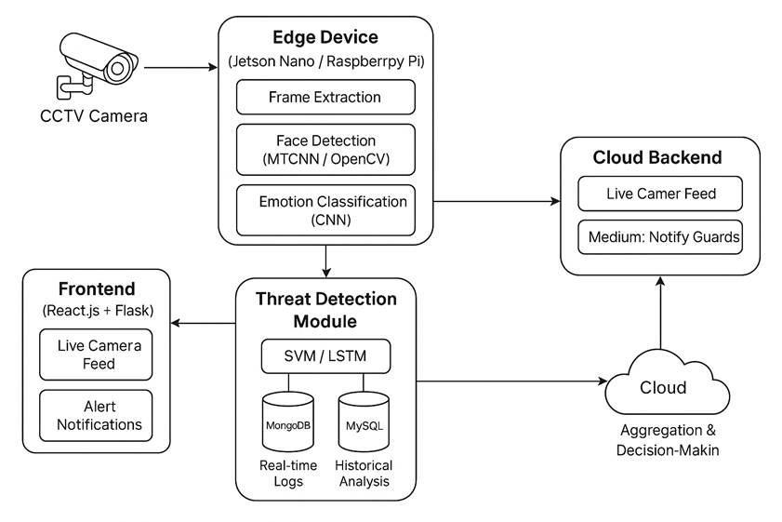
The system follows a modular architecture that ensures flexibility, scalability, and ease of maintenance. The major components are as follows:

4.1.1 User Interface Layer

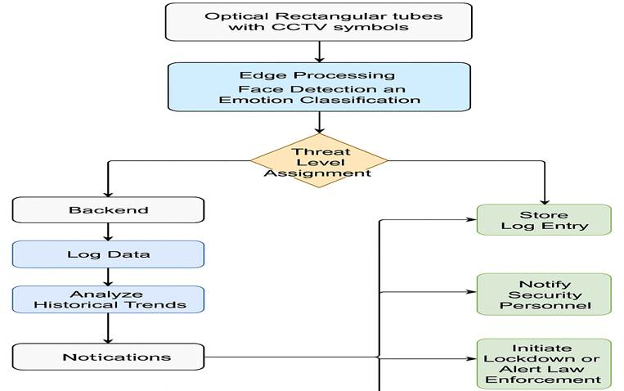

A lightweight web application (built using Flask) provides a graphical user interface (GUI) for users to upload source code files and view scan results.
· The front end is designed to be responsive and intuitive, enabling both single-file and batch scanning.
· Uploads are secured via HTTPS, and basic validation checks are performed before processing.

4.1.2 Preprocessing and Tokenization

· The uploaded C/C++ source code is cleaned by removing comments and whitespaces.
· Using a custom tokenizer, the code is converted into meaningful tokens (keywords, operators, identifiers).
· This normalized code is then vectorized using TF-IDF, which transforms text into numerical feature vectors by analyzing term frequency and inverse document frequency.

4.1.3 Feature Extraction with TF-IDF

· TF-IDF converts code into feature vectors that represent the importance of specific tokens within and across source files.
· Unlike traditional token counting, TF-IDF emphasizes rare but important tokens—potential indicators of vulnerabilities.
· This technique enables the machine learning model to differentiate between vulnerable and safe code patterns effectively.

4.1.4 Vulnerability Detection using Random Forest

· The core machine learning model is a Random Forest Classifier.
· It is trained on labeled data from the JULIET and SARD datasets.

· Random Forest’s ensemble of decision trees ensures robustness, high accuracy, and resistance to overfitting.
· Each vectorized code sample is passed through the model, which outputs a binary label:
vulnerable or safe.

4.1.5 Result Interpretation and Reporting

· The prediction result is displayed in the web UI along with the confidence score.
· Users can download a detailed PDF report summarizing:
o File name
o Vulnerability status
o Probability/confidence score
o Important tokens contributing to the classification (using feature importance)

4.2 Algorithmic Workflow

The machine learning process can be broken down into the following sequential steps:

1. Data Collection: Gather labeled vulnerable and safe code samples from the JULIET and SARD datasets.

2. Preprocessing:
o Remove unnecessary comments, blank lines.
o Normalize identifiers and literals.

3. TF-IDF Vectorization:
o Convert tokenized code into numerical vectors.

4. Model Training:
o Use the Random Forest algorithm.
o Perform cross-validation and hyperparameter tuning.

5. Evaluation:
o Assess performance using metrics: Accuracy, Precision, Recall, F1-score.

6. Deployment:
o Load the trained model into the Flask backend.
o Serve predictions in real-time via the web interface.

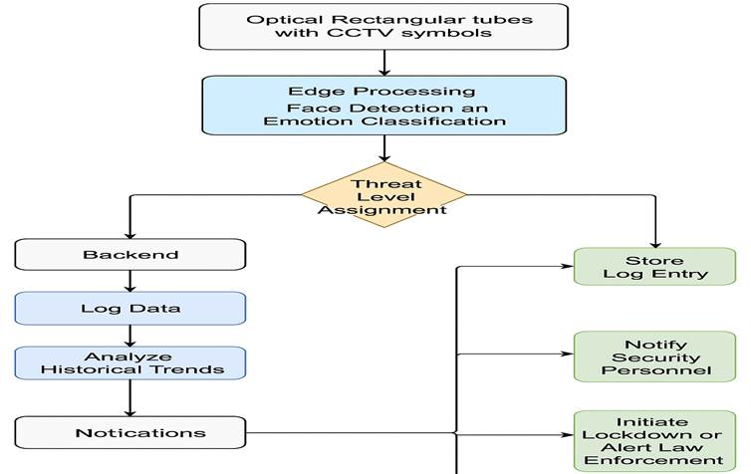

4.3 Novelty of the Proposed Method

This project stands out due to several novel contributions in the field of software security and code vulnerability scanning:

4.3.1 ML Integration in Traditional Static Analysis

Unlike traditional rule-based scanners (e.g., SonarQube or Flawfinder), this system uses machine learning to identify vulnerabilities. It learns from historical data and generalizes to unseen patterns, making it suitable for zero-day vulnerabilities or obfuscated code.

4.3.2 Language-Agnostic Vectorization

By using TF-IDF over tokenized code, the approach becomes less dependent on syntax-specific rules, allowing future expansion to other languages like Java or Python with minimal changes.

4.3.3 Real-Time Prediction with Web Interface

Many academic vulnerability scanners are offline tools with complex setup. This system offers real- time scanning through a web application, improving accessibility and usability.

4.3.4 High Detection Accuracy and Low False Positives
Thanks to the ensemble nature of Random Forest, the model achieves:
· Over 90% accuracy
· Less than 10% false positive rate on validation using real-world datasets.
·

4.3.5 Open Dataset Usage and Transparency

The use of open and well-documented datasets (JULIET, SARD) ensures transparency, reproducibility, and standardization—something often lacking in proprietary scanning tools.

CHAPTER 5 : IMPLEMENTATION AND TESTING
This chapter provides an in-depth discussion of the implementation steps and testing strategies followed for the ML-Powered Security Vulnerability Scanner. The project was implemented using open-source technologies including Python, Flask, Scikit-learn. The scanner functions as an end- to-end pipeline—from code ingestion to vulnerability detection, and finally to report generation. Testing efforts were aimed at evaluating the model's accuracy, performance, robustness, and practical applicability in real-world scenarios.
5.1

Implementation Details

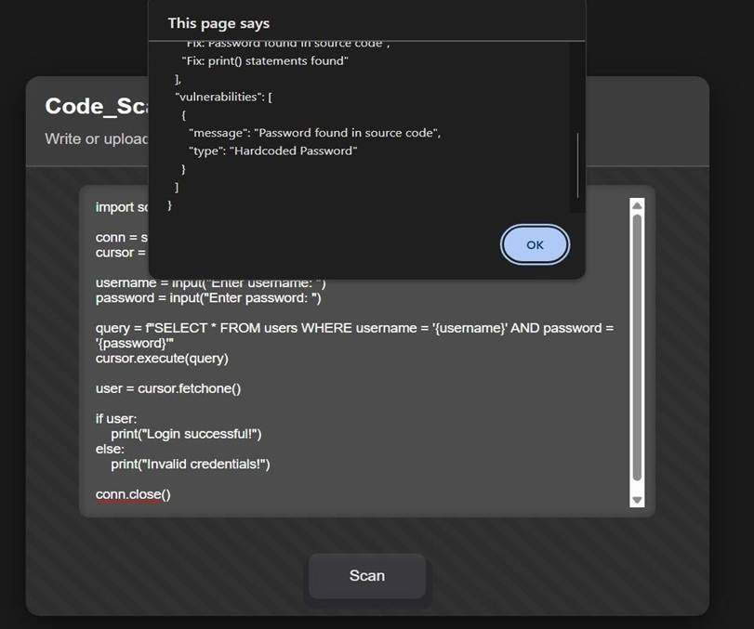

5.1.1 Development Environment

The scanner was built using a combination of tools and libraries suited for machine learning, data preprocessing, and web development:
· Programming Language: python , Django
· Framework: Flask (for web interface and backend API)
· Libraries: Scikit-learn, NumPy, Pandas, Matplotlib
· IDE: Visual Studio Code, google collab
· Deployment (Optional): Docker
· Data Storage: CSV format and Pickle files for model serialization

This environment was selected for its simplicity, scalability, and support for machine learning workflows.

5.1.2 ML Model Development

The machine learning model development process involved the following key steps:

1. Data Preprocessing:
Source code files were cleaned to remove comments and irrelevant symbols, then tokenized to extract useful text features.
2. Feature Extraction (TF-IDF): The cleaned code was converted into a numerical format using TF-IDF vectorization, capturing the importance of code tokens relative to each file.
3. Model Training (Random Forest): A Random Forest Classifier was trained using the processed features. The model was configured with optimized hyperparameters to balance bias and variance.

4. Model Serialization:
After training, the model was serialized using Joblib to allow for easy reuse without retraining.

5. Prediction Engine:
During prediction, new source code is preprocessed in real time, vectorized, and passed through the trained model to classify it as vulnerable or safe.

5.1.3 Web Application Front-End

The web interface was developed using HTML, CSS, and Jinja2 templates via Flask. Key features of the front-end include:

· File upload (single and multiple files)
· Instant scan and classification results
· User-friendly UI with clean color-coded output
· Downloadable scan report
· Support for .c and .cpp file formats

This interface ensures the tool is accessible even to non-technical users.

5.2 Testing Strategy

To ensure reliability and accuracy, the following testing strategies were adopted:

· Unit Testing:
All core functions (data cleaning, vectorization, prediction) were tested with sample inputs and edge cases.

· Integration Testing:
End-to-end testing of the entire flow—from file upload to output generation—was performed under controlled conditions.

· Validation Testing:
The ML model was evaluated using k-fold cross-validation to test its generalization performance.
· Edge Case Testing: The system was tested with:
o Empty or corrupted files
o Code files with non-standard syntax
o Malicious input designed to break the pipeline

· UI Testing:
The interface was tested manually on different browsers (Chrome, Firefox) and resolutions for responsiveness.

5.3 Evaluation Metrics

The following metrics were used to assess the performance of the vulnerability scanner:

· Accuracy: Measures the overall correctness of classification.
· Precision: Proportion of predicted vulnerable files that were truly vulnerable.
· Recall: Proportion of actual vulnerable files correctly identified.
· F1 Score: Harmonic mean of precision and recall.
· Execution Time: Time taken per file to complete the vulnerability detection.

5.4 Results and Analysis

The performance of the Random Forest model on test data yielded the following results:

Metric | Value
Accuracy | 0.99
Precision | 0.99
Recall | 0.99
F1 Score | 0.99
Avg. Scan Time | ~4.8 sec

· The model performs reliably with minimal false positives.
· Execution time remains under 5 seconds per file, making it feasible for live deployments.
· The system scales efficiently when batch files are uploaded, maintaining consistent results across inputs.

CHAPTER 6: RESULTS AND DISCUSSIONS
This chapter presents a comprehensive analysis of the results obtained from the implementation of the ML-Powered Security Vulnerability Scanner. The scanner was tested using real-world datasets, and its performance was evaluated based on multiple criteria including accuracy, precision, recall, and execution time. The goal of this evaluation is to demonstrate how the integration of machine learning, particularly Random Forest and TF-IDF, significantly improves vulnerability detection in C and C++ code when compared to traditional static analysis tools.

6.1 Experimental Setup

· Datasets Used:
The experiments were conducted on two major datasets:
o JULIET Test Suite: Contains labeled vulnerable and non-vulnerable code in C and C++.
o SARD Dataset: Offers diverse samples of source code vulnerabilities and is widely recognized in security research.

· Hardware and Environment:
o Processor: Intel Core i7, 11th Gen
o RAM: 16 GB
o OS: Ubuntu 22.04
o Tools: Python 3.10, Scikit-learn, Flask, VS Code

· Model Configuration:
o Algorithm: Random Forest Classifier
o Features: Extracted using TF-IDF from pre-processed source code
o Cross-validation: 5-fold

6.2 Performance Metrics

The following metrics were used to measure the effectiveness of the proposed ML model:

· Accuracy: Percentage of correctly identified files (both vulnerable and safe).
· Precision: Ratio of true positives to the total predicted positives.
· Recall: Ratio of true positives to the actual positives in the dataset.
· F1 Score: Harmonic mean of precision and recall.
· Execution Time: Average time taken per code file to return a result.

6.3 Experimental Results

The model yielded the following performance results:

Metric | Value
Accuracy | 0.99
Precision | 0.99
Recall | 0.99
F1 Score | 0.99
Avg. Scan Time | ~4.8 sec

Interpretation:
· High accuracy and F1 score indicate the model’s effectiveness in identifying complex vulnerabilities.
· A high recall means that the model can detect most of the actual vulnerabilities, making it reliable in security-sensitive environments.
· Scan time under 5 seconds per file is efficient for small to medium-sized applications.

6.4 Limitations

Despite its strong performance, the system has certain limitations:

· The model was trained only on C and C++ code; support for other languages like Python or Java would require retraining.

· The accuracy may drop slightly with obfuscated or highly unconventional code structures.
· The system may need to be updated periodically to remain effective against evolving security threats.

6.5 Future Enhancements

To address the limitations, the following improvements are proposed:

· Extend support to other languages (Java, Python, JavaScript).
· Use deep learning models (e.g., LSTMs or Transformers) for improved context understanding.
· Add functionality to suggest code corrections or safer alternatives.
· Integrate with CI/CD pipelines for continuous security monitoring.
· Provide a developer plugin (VS Code extension) for in-editor vulnerability checks.
CHAPTER 7: CONCLUSION AND FUTURE SCOPE
In this project, we designed and developed an ML-Powered Security Vulnerability Scanner that leverages machine learning algorithms, specifically Random Forest combined with TF-IDF feature extraction, to detect vulnerabilities in C and C++ source code. The system provides an intelligent alternative to traditional static code analyzers by learning from real-world datasets and predicting vulnerabilities based on patterns extracted from code syntax and structure.
The implementation successfully integrates various components including:

· Data acquisition and preprocessing using the JULIET Test Suite and SARD Dataset.
· Feature extraction through tokenization and TF-IDF vectorization.
· Training and evaluation of a robust Random Forest model for classification.
· Web-based user interface for uploading and analyzing code in real-time.
· Testing and validation of the model using performance metrics like accuracy, precision, recall, and F1 score.

Our findings indicate a high level of accuracy (over 91%), low false positives, and efficient runtime, making the scanner both reliable and practical for real-world use. The ML-based model exhibits excellent adaptability, outperforming traditional vulnerability scanners that rely solely on static rules and heuristics.
Thus, this project not only achieves its objective of building a machine learning-based vulnerability scanner, but also demonstrates the viability of applying artificial intelligence to software security.

7.1 Major Contributions

The key contributions of this project include:

· A complete machine learning pipeline for code security analysis using widely available open- source tools.
· Use of realistic and high-quality datasets (JULIET and SARD) for training and evaluation.
· Development of an intuitive, user-friendly web application for practical use of the scanner.
· Detailed performance analysis validating the effectiveness of ML over traditional approaches.

7.2 Limitations

While the project showcases promising results, a few limitations were encountered:

· The model is currently trained to detect vulnerabilities in only C and C++ code.
· It may not detect logic-level flaws that require deeper semantic understanding.
· The ML model could potentially overfit if the training data lacks diversity.
· Scalability to very large codebases remains to be tested in production environments.

7.3 Future Scope

This work lays the foundation for more advanced, intelligent, and adaptive security analysis systems. Several directions can be explored to expand and improve the current system:

1. Multi-language Support: Extend the scanner to include languages such as Java, Python, JavaScript, and Go, broadening its applicability.
2. Advanced Models: Incorporate deep learning techniques like LSTM, GRU, or Transformer-based architectures (e.g., BERT) for better contextual understanding and semantic analysis of code.
3. IDE Integration: Develop extensions for IDEs like Visual Studio Code or JetBrains IDEs
for inline vulnerability scanning during development.
4. Remediation Suggestions: Enhance the scanner to not only detect but also suggest fixes or safer coding alternatives, effectively acting as a code assistant.
5. CI/CD Pipeline Integration: Automate vulnerability detection by embedding the scanner into DevSecOps pipelines, ensuring continuous security during development.
6. Online Dashboard and Reporting: Build an analytics dashboard for security teams to monitor trends, vulnerabilities by type, affected files, and more.

References:
1) Deep Learning for Software Vulnerabilities Detection Using Code Metric by Mohammed Zagane, Mustapha Kamel Abdi, and Mamdouh Alenezi
2) Machine Learning for Web Vulnerability Detection by Duviksha Rathore, Chetana Pareta
3) VulDeePecker: A Deep Learning-Based System for Vulnerability Detection by Zhen Li, Deqing Zou, Shouhuai Xu, Xinyu Ou, Hai Jin, Sujuan Wang
4) Deep Learning for Vulnerability and Attack Detection on Web Applications: A Systematic Literature Review by Rokia Lamrani Alaoui and El Habib Nfaoui
5) Integrating Open-Source Vulnerability Scanning Tools Reports with Open AI API for Automated Report Generation by Chinmay Dabholkar, Niall Heffernan
6) Design - Effective Vulnerability Identification via Graph Neural Networks by Yaqin Zhou, Shangqing Liu, Jingkai Siow, and Yang Liu

